

*Software Quality Engineering*  
*LabTask 04*

Name : Muhammad Shamoil  
Section : BSSE – V – A  
Date: 17th Oct , 2025  
Submitted To : Sir Naseer Jan

Contents

Task 01 1

***Edge*** 1

***Chrome*** 2

FireFox 2

Task 02 3

# 

# Task 01

## ***Edge***

## ***Chrome***

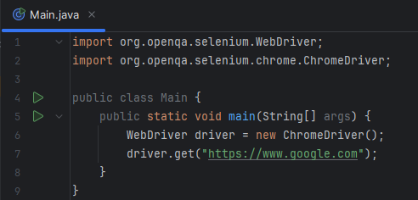

## FireFox

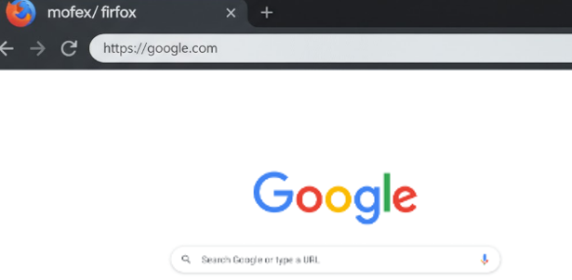

# Task 02

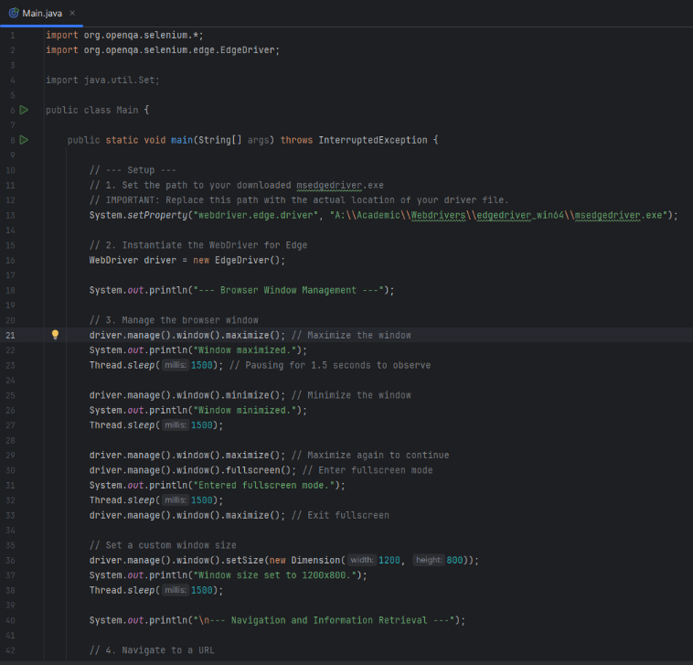

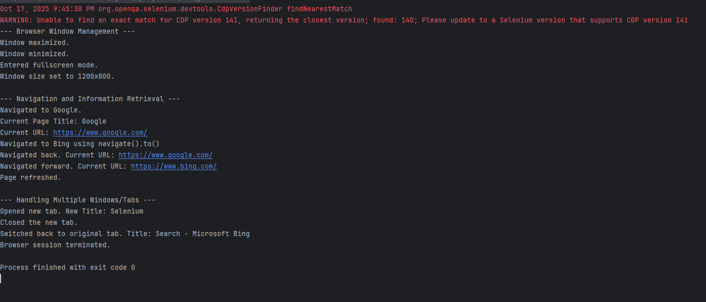

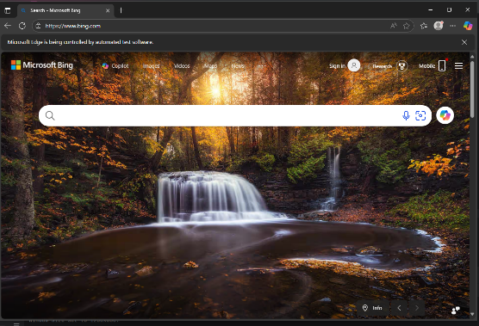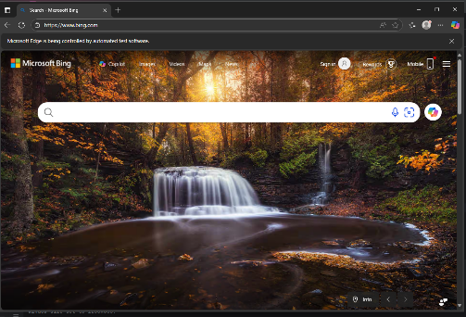

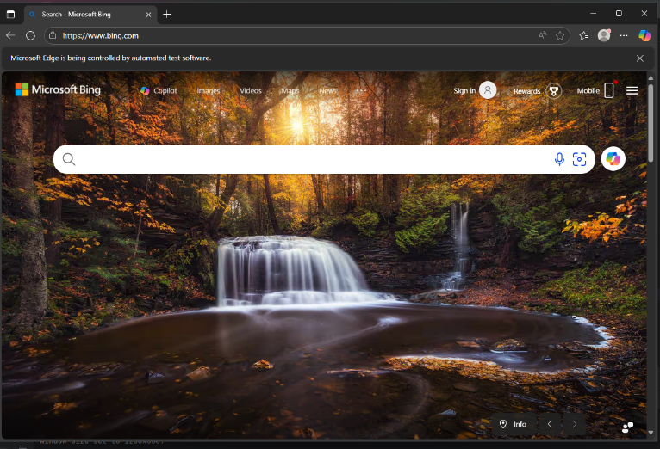

***[Window Closed]***